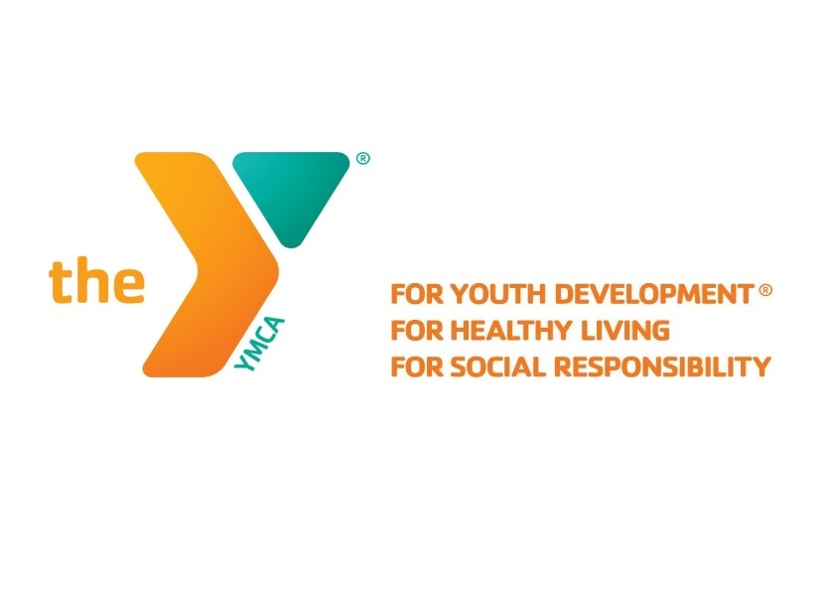

Child Watch

Child roster system with sign in tracking and reporting.

**Core Tech Development Solutions**

**Published: 5/3/2018**

**Business Customer: Kathleen Price Family YMCA**

Authors:

* Christian Ore Development Manager
* Jeremy Adams Senior Developer
* Kayla Sparklin Application Developer
* Coleman Wilson Web Designer

Table of Contents

Revision History 2

Request for Development 3

Business Customer 3

Development Team 3

Executive Summary 4

YMCA Background 4

Project Objective 4

Product Requirements 5

Time & Budget Considerations 5

Summary 5

Business Requirements 6

Overview 6

Current Business Process 6

Deficiencies in Current Process 6

Proposed Business Process 6

Solutions to Existing Deficiencies 6

Project Stakeholders 7

Consumer 7

Development Team 7

Requirements 8

Functional Requirements 8

Reporting 9

User Interface 10

Login Process 10

Registration 12

Sign Out 12

Cost of Development 13

Project Timeline 13

Considerations 13

Diagrams 14

Entity Relationship Diagram 14

Data Flow Diagram 15

Use Case Diagrams 16

System 16

Registration 17

Sign In 18

Sign Out 19

Administrator Workflows 20

Memorandums 21

Date: 2/15/2018 21

Date: 2/22/2018 22

Date: 3/1/2018 23

Date: 3/15/2018 24

Date: 3/22/2018 25

Date: 4/12/2018 26

Date: 4/26/2018 27

# Revision History

|  |  |  |
| --- | --- | --- |
| Date | Author | Description |
| 3/3/2018 | Christian Ore | Original Created |
| 4/5/2018 | Christian Ore | Added Organization chart for team management |
| 4/30/2018 | Christian Ore | Added updated diagrams to SRS |

# Request for Development

## Business Customer

Organization: Kathleen Price Bryan Family YMCA

Location: 501 W Market St, Greensboro, NC 27401

Project Contact: Bethany Williard, Membership Director

[Bethany.williard@ymcagreensboro.org](mailto:Bethany.williard@ymcagreensboro.org)

336-478-9622

## Development Team

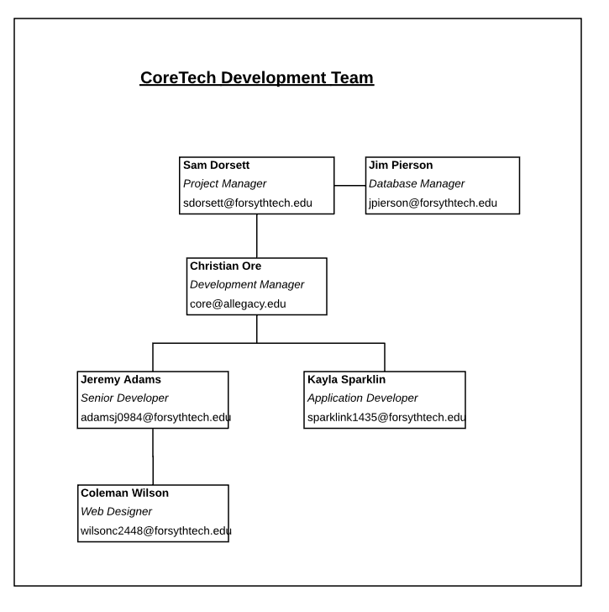

## Executive Summary

The YMCA of Greensboro has expressed interest in software to structure and store data gathered from the Child Watch program. The program is intended to allow parents to use YMCA facilities while their children play in special zones of the YMCA during their stay. Parents must fill out a sheet of paper each time they visit the facility with their name, the child's name, and the location of the child. They then are given bands to wear with a unique number identifying them both to be monitored in the program. The company would like this process to be digitalized for easier sign in and report pulling.

## YMCA Background

The YMCA is a non-profit organization dedicated to helping others live up to their highest potential by offering wellness services in a family environment. The organization has been around for over 125 years and located all over the country. The services provided include workout facilities, indoor swimming and spa, as well as outdoor tracks and fields. They believe in helping others to develop their spirit, body, and mind and most importantly, the progression of our youth toward greater opportunities.

## Project Objective

The YMCA has created a Child Watch program that allows parents to use the facilities while their younger children are supervised by YMCA staff in special activity locations within the branch. The program is currently implemented in two YMCA branches: Alexander Spears Family YMCA and Kathleen Price Bryan Family YMCA. Currently, members must write personal information about themselves and their child on a sign in log. Once logged, they receive bands with matching numbers to identify parent to child. They must show a staff member these bands before leaving the building. An adult and child without a band or band with a different number from each other cannot leave together. Every process is manual, and there is no business intelligence for management. The goal of the proposed development is to build a software suite to eliminate these deficiencies. There will be different user interfaces for sign in, registering, and reporting to allow each piece of the process to work independently.

## Product Requirements

The project will be required to meet the following criteria to fulfill the customer’s basic needs upon delivery.

* Provide a sign in screen for parents to check in and out. They will enter their YMCA barcode and a secret PIN to check in.
* After checking in, the system will provide a unique number for the parent to write on their family bands for identification.
* Front desk staff must be able to register a member and children for the service.
* Administrators will have a business intelligence view where reports can be queried and downloaded.
* Font desk staff will be able to check out to a family after matching and removing their bands.
* Administrators will be validated by username and password.

## Time & Budget Considerations

The system will need to be designed, implemented, and deployed no later than May 1st, 2018 to ensure there is ample time to install and train users. Also, any post-delivery faults found will need to be addressed before completion. The location of deployment is one hour away from our place of development. We will maintain a tight deadline to allow for driving back and forth to the site in Greensboro. Development services such as web hosting, DNS forwarding, and documentation systems are being provided by third-party donations. There will be no need to invest in development platforms to run the product during delivery and up to six months after product release. After this point, the YMCA will be responsible for finding these services or continue with paid plans with the existing servicer.

## Summary

The YMCA is in need for better data storage for their Child Watch program. The program is a great help to parents by helping watch children and provide security and assurance that their children are safe. There are companies that have produced similar products however they are very expensive. Our small team of developers can design and implement a system with the functionality they require with minimal overhead for the YMCA.

# Business Requirements

## 

## Overview

### Current Business Process

The YMCA has implemented a child watch program where parents can bring younger children for YMCA staff members to watch while they use the facilities. The goal of this is to bring in more people to the company knowing they have child watch options. To use this service, members must manually write down contact information, child name, and sign in information when coming in. From here, the parent and child are both given bands with matching numbers. Once sign in is complete, parents are free to use the YMCA facilities and their child goes to one of two play zones. Parent and child are checked prior to leaving to ensure both band numbers match. Currently all reporting, logging, and sign in/out is done manually and records are kept on paper.

### Deficiencies in Current Process

With everything manual and on paper, it is difficult to keep accurate data. Members can be rushed and forget to fill in information. Also, there is nothing other than a sheet of paper to track sign in status. This makes it difficult to monitor the number of children while they are in the facility. Management must go through these sheets to build reports and analyze the process to make changes to points of concern.

### Proposed Business Process

We will build a multi user system to handle tracking data and creating reports for the YMCA child watch program. The system will be entirely web based, operating in the cloud and user interfaces being web links. Data will instead be kept in a singular database that links the current member information to their check in information. The system will incorporate business intelligence to provide reports and data analytics to management to easily make decisions based on program usage. Information will be stored securely and travel through encrypted channels to each piece of the system.

### Solutions to Existing Deficiencies

By removing anything manual, we can guarantee data integrity by the constraints set by the business rules. This will ensure that data remains consistent and accurate always. Members will be able to sign in faster once they have registered for the program. A computer will be available to members upon arrival to type in a custom pin to sign in themselves and their child. The decrease in sign in and sign out time will increase member acceptance and approval of the program.

## Project Stakeholders

The following section describes the stakeholders in the project and his/her role.

### Consumer

1. Bethany Williard – Membership Coordinator
   1. Primary contact for the project at the YMCA
   2. Approve final deployment of product

### Development Team

1. Christian Ore – Development Manager
   1. Review designs and implementation.
   2. Provide updates to management.
   3. Liaison to the YMCA for project requirements.
   4. Develop backend database and web services
2. Kayla Sparklin – Database & BI Development
   1. Develop database structure and implementation
   2. Create procedures for use within project
   3. Create and support Business Intelligence for project requirements
3. Coleman Wilson – Front End Development
   1. Responsible for building the sign in portion of the web application
   2. Create a method for logging
4. Jeremey Adams – Application Development
   1. Creating a subsystem to register and sign out members
   2. Integrate SignalR push notifications to keep content up to date

## Requirements

### Functional Requirements

1. Sign in/ Sign out
   1. Members will have a dedicated view where they can sign in to child watch.
   2. Sign in requires the YMCA barcode and a unique PIN created by the member.
   3. Staff will have a view to check band numbers and sign out a member.
   4. Once signed in, a unique six-digit code is provided to the member to write on their bands.
   5. Members should be able to sign in multiple children and choose corresponding locations.
2. Registration
   1. Staff can add new members using a dedicated view. This view will take member data and their unique YMCA member id to match to the existing YMCA database.
   2. Once registered, members can sign in on their own.
3. Update
   1. A page should allow querying of existing member data to change any field, accept for the pin, this is changed by the member only.
   2. A page should allow updating child information.
   3. A form should allow a comma separated file to be attached to update member active status. The file will have the YMCA member id and a Boolean value indicating active membership.
4. Administration

Administrators should be able to complete the following:

* 1. Add a new administrator to the system
  2. Pull and print reports
  3. Override sensitive data (i.e. PIN and other member data)

1. Password Recovery
   1. Have system to update passwords should an admin forget their password

### Reporting

The YMCA child watch system should be able to generate the following reports in its business intelligence system for the user.

1. Head Count
   1. This report will show the count of children in the program partitioned by time increments.
2. Total Enrollment
   1. One version of this report will show all members in the program.
   2. A second version will show all children active in this program.
3. Current Sign in
   1. This report should show members and children currently signed into program.
   2. Report should update as members enter and exit for the day.
4. Check in/out history
   1. Show sign in records filtered by user search parameters

## User Interface

### Login Process

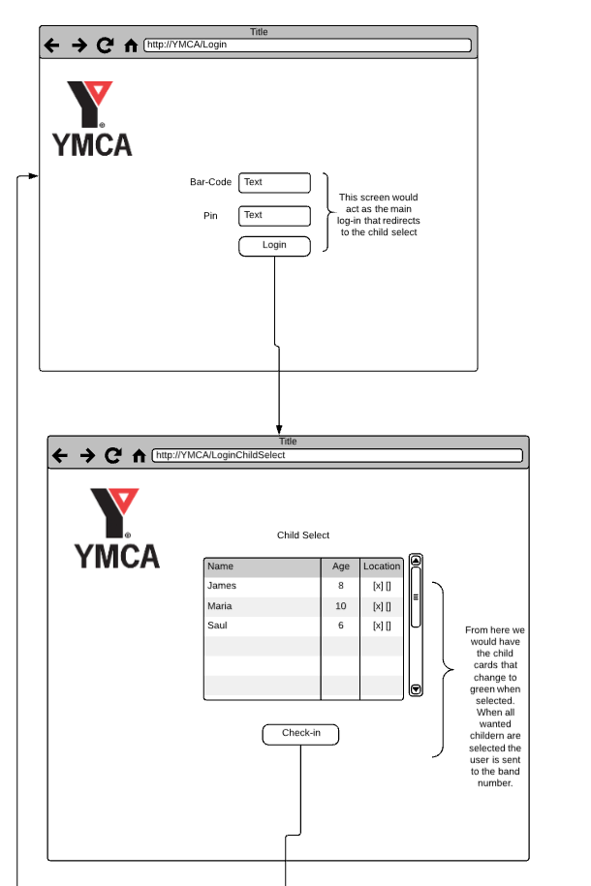

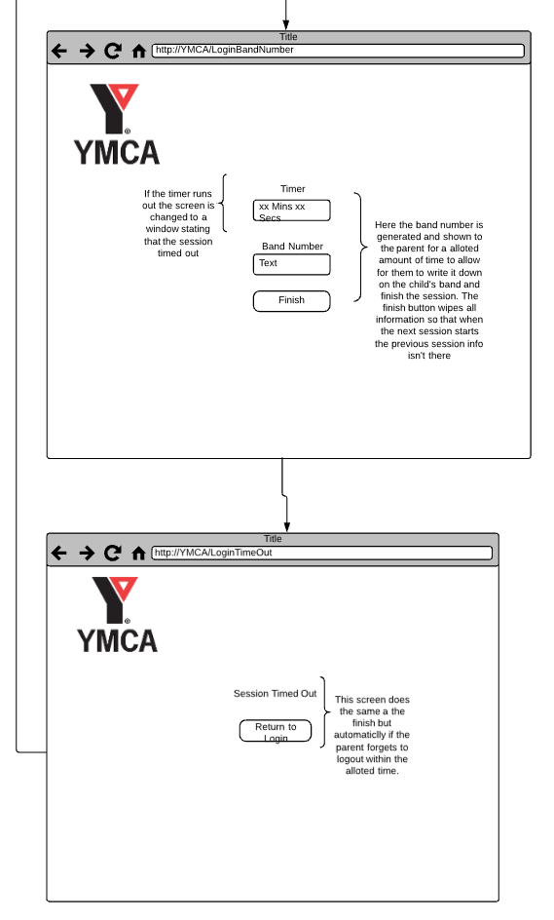

### Registration

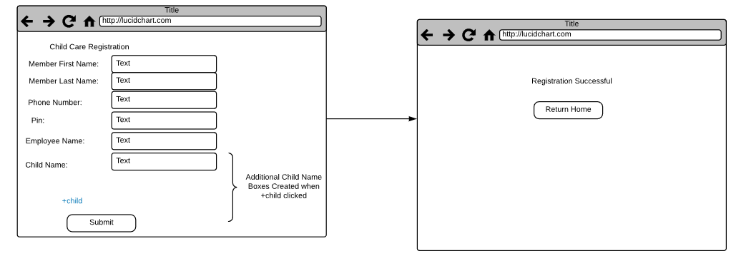

### Sign Out

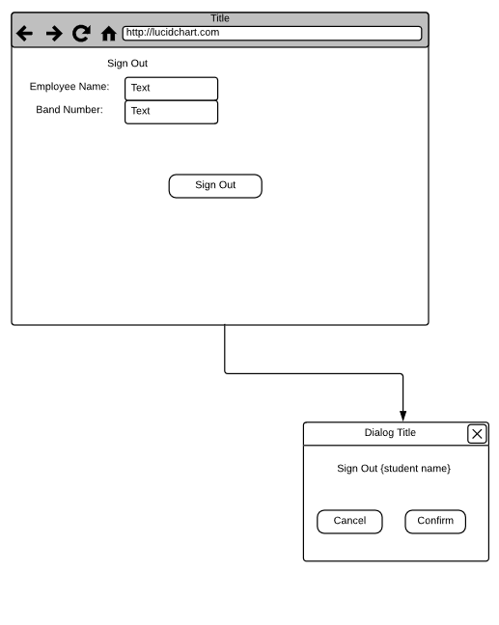

## Cost of Development

|  |  |  |  |
| --- | --- | --- | --- |
| Section | Rate | Amount | Total |
| Labor | $22/hr. | 160 hours | $3520.00 |
| Database Service | $5/month | 4 months | $20.00 |
| Web Application Hosting | $11/month | 4 months | $44.00 |
| Estimated Total |  |  | $3584.00 |

## Project Timeline

|  |  |  |
| --- | --- | --- |
| Date | Event | Description |
| 3/1/2018 | Project Design | Create working design and analyze system. |
| 3/7/2018 | Implementation | Begin building of system |
| 4/20/2018 | Anticipated Project Completion | Project should be complete or wrapping up development |
| 4/25/2018 | Quality Assurance | Complete testing and patches to bugs |
| 4/30/2018 | Final Deployment | Deliver project to YMCA |

# 

## Considerations

1. The YMCA is a non-profit and does not have a major budget to implement this system. Even with the donation of development time, the project will need to keep resources used by the system such as hardware, hosting, DNS and other necessities to a minimum. We will modify the build to accommodate current hardware and resources the local YMCAs already have on site to prevent buying additional items or software.
2. To ensure deployment has no difficulty, the project will need to complete implementation by April 20th, 2017 to ensure enough time for testing and driving to the Greensboro site to install and to train the staff.
3. Once the system is deployed, there will be little support from the development team and will become a released and unmaintained product. The quality of the software will need to be as high as possible to ensure this product can operate without technical support or future patches.
4. The system will run in a web environment using a hosted web service. The system will need a way to ensure only authorized computers can connect to get sensitive information. In addition, any moving data will need to be encrypted as it flows from the server to the client.

# Diagrams

## Entity Relationship Diagram

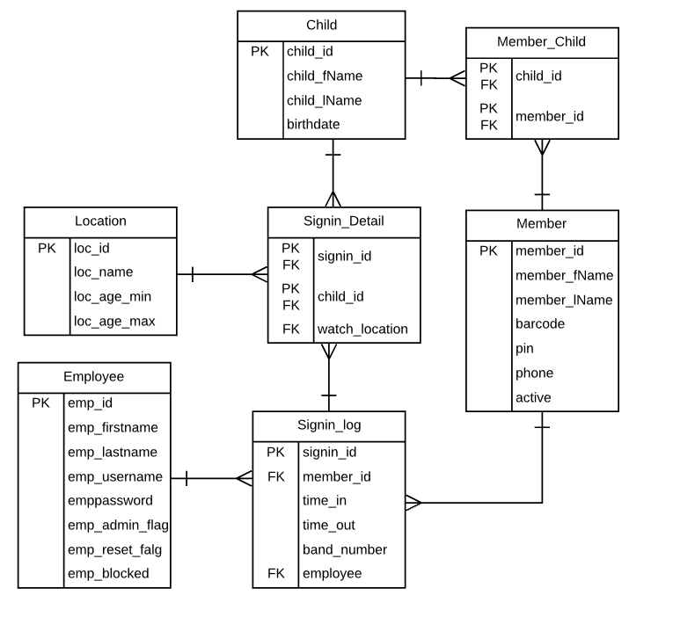

## Data Flow Diagram

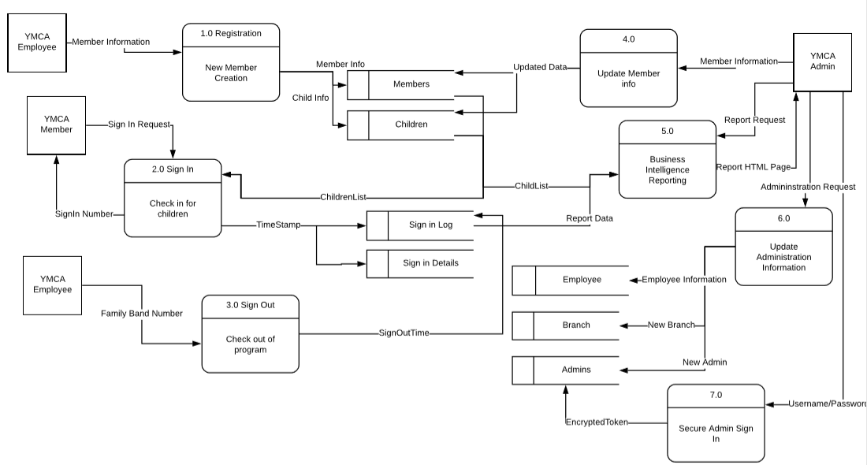

## Use Case Diagrams

### System

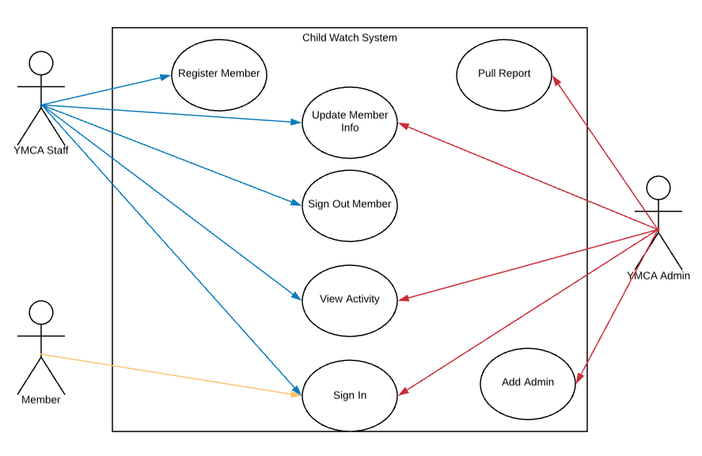

### Registration

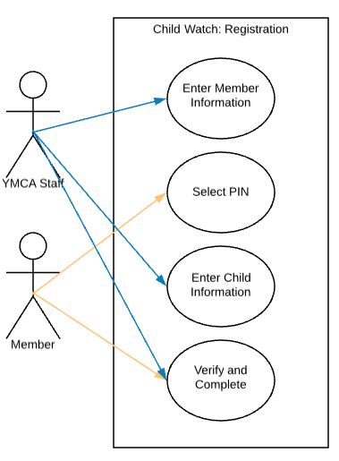

|  |  |
| --- | --- |
| New Child Watch Member Registration | |
| Actor | Member, YMCA Employee |
| Description | A YMCA member requests use of Child Watch services for first time and information is entered into the system to allow for individual sign in. |
| Successful Completion | 1. Member approaches YMCA front staff about registering into program  2. YMCA staff and member enter all relevant info about member and children  3. Member selects and enters PIN for use  4. Registration is completed |
| Alternative | 1. Member approaches YMCA front staff about registering new child into program  2. YMCA Staff pull current member information  3. Staff enter information on new child  4. Additional Child Registration completed |
| Precondition | Active YMCA member needs entry into Child Watch Program database |
| Postcondition | Member has all relevant information in system and can continue with individual sign in when utilizing Child Watch program |

### Sign In

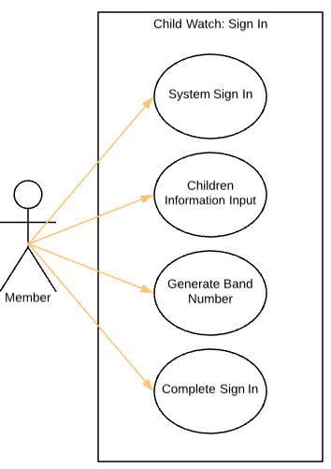

|  |  |
| --- | --- |
| Individual Member Sign in to Child Watch Program | |
| Actor | Member |
| Description | YMCA Member signs child into the Child Watch program |
| Successful Completion | 1. Signs in using YMCA barcode and personal PIN  2. Selects children to sign in  3. Gets generated band number and applies it to needed bands  4. Acknowledges completion  5. System resets for next member |
| Alternative |  |
| Precondition | Member needs to sign in child to be watched by YMCA |
| Postcondition | Child is signed in to Child Watch Program |
| Assumption | Member is active at the YMCA and has completed one-time registration for the system already. |

### Sign Out

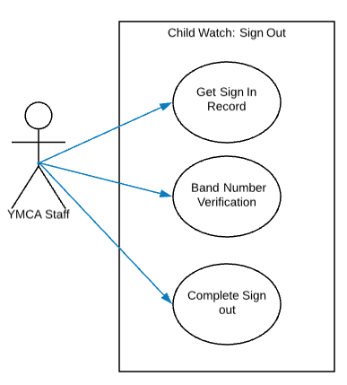

|  |  |
| --- | --- |
| Sign Out of Children from program | |
| Actor | YMCA Staff |
| Description | YMCA Staff verifies member leaving with child and completes the sign in log |
| Successful Completion | 1. YMCA Staff pulls up member sign in log for child  2. Staff verifies band numbers match what is in the system  3. Staff enters their name  4. Staff completes the log providing sign-out time |
| Alternative |  |
| Precondition | Member needs to leave with child |
| Postcondition | Member and child leaves with completed sign in log |
| Assumption | Staff available to complete verification |

### Administrator Workflows

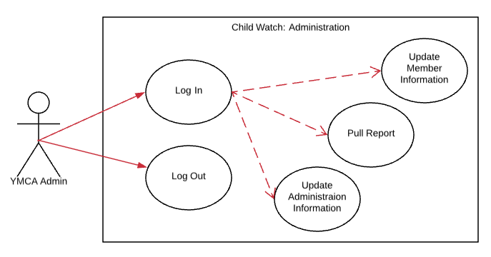

|  |  |
| --- | --- |
| Sign Out of Children from program | |
| Actor | YMCA Administrator |
| Description | YMCA Administrator uses secure log in to complete management tasks |
| Successful Completion | 1. Administrator enters username and password  2. Completes any needed tasks  a. Updates member information  i. Selects Member file  ii. Enters new information  iii. Closes file  b. Updates administration level information  i. Selects admin related file  ii. Enters new information  iii. Closes file  c. Runs BI reporting tasks  i. Selects Report to run with parameters  ii. Runs report  iii. Views Report in preferred format  3. Logs securely out of the session |
| Alternative |  |
| Precondition | Administrator needs to utilize management functionality |
| Postcondition | Management tasks completed securely |
| Assumption |  |

# Memorandums

## Date: 2/15/2018

CoreTech Development

To: Sam Dorsett

From: Christian Ore

CC: Jim Pierson

Re: Status Report: Week 1

Comments:

The YMCA child watch application is currently under development. We have met with Bethany Williard from the YMCA to gather requirements. We have drafted a model of the system and its sub-components. The model shows the login, business intelligence, and administration components. Kayla has put together and entity relationship diagram for the database. Coleman and Jeremy have created mockups for the login and sign up screens. Finally, I have created a design for a web service that the client applications can use to connect to the database and increase our security. At this point, we have a strong set of designs and can begin working potential problems that can appear at implementation time. We are planning to conduct basic card sort testing to ensure our designs give an accurate representation of the use of the system.

## Date: 2/22/2018

CoreTech Development

To: Sam Dorsett, Jim Pierson

From: Christian Ore

CC: Kalya Sparklin, Coleman Wilson, Jeremy Adams

Re: Status Report: Week 2

Comments:

The design and analysis of the YMCA has gotten off to a great start. We now have a normalized entity relationship rough draft for our database. We are still combing through the design to ensure it will meet business rules and prevent data errors. Kayla has created a database script to build the tables and enforce constraints based on the ERD. Coleman has created mockups for the login page of our application. This login page is where members will input their barcode and pin to sign in.

To create a secure medium of content delivery, I have created a web service that will serve as our primary data source. This web service will be accessed by all applications to get information needed from the database. I was also able to setup our base infrastructure on Microsoft's Azure. We now have a working database, website, and webservice application being hosted and ready for development. Jeremy has worked on integrating our application with SignalR which framework for immediate content delivery to clients is. We will use this to keep our application updated in real time.

This week we formalize everything into a scope document to ensure our initial documentation is accurate and the project is ready to be implemented. Anything that we have not fully covered, we will have a follow up interview with Bethany before we begin writing code.

## Date: 3/1/2018

CoreTech Development

To: Sam Dorsett, Jim Pierson

From: Christian Ore

CC: Kayla Sparklin, Coleman Wilson, Jeremy Adams

Re: Status report: 3/8/2018

Comments:

The team has been making progress creating the implementation for project. The front-end team have developed the alpha version of our screens with basic styles and some functionality. The front end is currently working with local test data. We hope to integrate this into the database in the following week. We are having some difficulty getting the connection from client to server and are troubleshooting this issue. However, the team is still able to test with random generated data to continue moving forward. Our database administrator has been setting up test data for our primary testing server so that we have plenty of cases to experiment with. We have scripts to add new members and children so that we can hook up the sign in part of the application by Wednesday 3/14/2018. Other than these minor issues we are having little difficulty and have not had to reconfigure any designs at this time.

## Date: 3/15/2018

CoreTech Development

To: Sam Dorsett, Jim Pierson

From: Christian Ore

CC: Kayla Sparklin, Coleman Wilson, Jeremy Adams

Re: Status report: 3/15/2018

Comments:

Our group has made great strides in development of the Child Watch application. The registration section of the application has a working front end that is styled to mimic the current working theme of the YMCA. We were able to integrate the front end with the web service and begin adding data. We have had some issues with connectivity. Our biggest issue was ensuring that the web service and the application live on the same domain. We encountered authentication errors in testing when this wasn’t the case. There is an API now for the web service so that other applications can make use of the same interfaces and code that the system is being designed around for extra compatibility. We hope to have a working registration and sign in section within the next two weeks. We will begin architecting the business intelligence portion of the website in tandem as everything else comes to a working point in its development cycle.

## Date: 3/22/2018

CoreTech Development

To: Sam Dorsett, Jim Pierson

From: Christian Ore

CC: Kayla Sparklin, Coleman Wilson, Jeremy Adams

Re: Status report: 3/22/2018

Comments:

We have had to take a diversion in building our web service API. The YMCA computer structure will cause us issues when implementing the code, we have if we do not update our current delivery protocol. We received a cross domain error when trying to use a similar setup. In our scenario, their database will live on a different system than the web service which will cause these exceptions to be thrown. To remedy this, we will take our existing web service code and place them in a local API library with a configuration setting to use either. This will use more classes that can be called by either code. This will allow us to focus on the local API for connecting to the database but not compromise our future goals of attaching to a much larger network. Since this will be a pilot, this is a better development strategy with less overhead and risk for our current delivery date. This API is about 75% and is testing well updating our database records. We have also already integrated pieces of it into the front-end design and getting some preliminary user feedback. Even with this minor setback, we have a good hold on our end goal and our work flow for the remainder of the project is solid. We have mapped out our use cases to be sure that we fulfil all our end users needs and will be placing these to the test when our quality assurance time comes around.

## Date: 4/12/2018

CoreTech Development

To: Sam Dorsett, Jim Pierson

From: Christian Ore

CC: Kayla Sparklin, Coleman Wilson, Jeremy Adams

Re: Status report: 4/12/2018

Comments:

We have made considerable progress over the past few weeks to our project. Our most notable change was transitioning from a web service framework to support our back end into a dedicated API. At this time, most of the objects are created and working correctly in the API. We have more testing to do before officially asserting the remainder of the framework to be production ready. The business intelligence portion of the application is now designed and running in the browser. We have started integrating it with the database to load reports in real time. Jeremy has worked on moving each developer project into a single and deployable product that we can load on a test machine. Our goal is to fully consolidate the code and take a bare Windows pc to determine any difficulties we may face in installing this product. Our member login portal is being styled to mimic the rest of the application. We must adjust some of these styles based on the dynamic changing HTML when the member is loading information from signing in. So far, this sign in process is working and efficient but we will be conduct more thorough testing in the next week. It is my ambition to have the product workable and for initial testing install by end of next week.

## Date: 4/26/2018

CoreTech Development

To: Sam Dorsett, Jim Pierson

From: Christian Ore

CC: Kayla Sparklin, Coleman Wilson, Jeremy Adams

Re: Status report: 4/26/2018

Comments:

Our project is ending to meet our deadline. My team is currently in testing phases and finding system faults to diagnosis and patch. Kayla has patched two bugs in the business intelligence portion of the application. She has also added the ability for the user to select all as an option which will be a huge bonus to the user when trying to read the data. We have better styles through the application now. We have implemented some mobile responsiveness to ensure if the page is resized we can keep a good layout. Our models in MVC have been given extra validation. Jeremy has been testing and troubleshooting some of the known error responses. We are ensuring that our users have as much knowledge about a system fault as possible so that the forms remain usable and that they can communicate these issues to us if they are severe enough. Finally our documentation is being done alongside our final testing so that we can ensure we have help, installation, and architecture documentation for the system.